INSTRUCTION

Residual torque measurement with the”Back to mark” method.

When a screw joint has been left for a longer time (>10 hours) and/or exposed to external load or heat, or when increased stresses on the screw material must not be generated during measurement, residual torque is measured by means of “Back to mark”.

This is done in the following way:

1. Identify the joint of interest

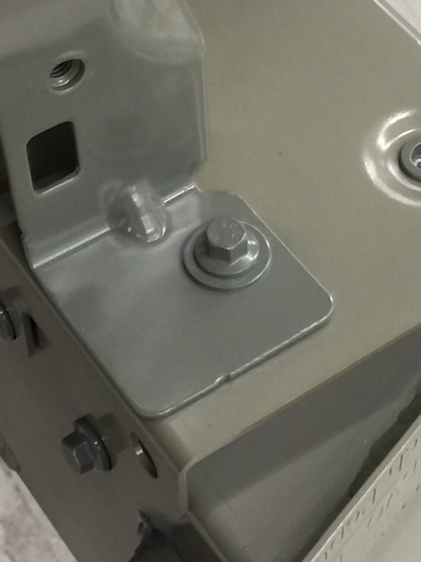

1. Make a mark from the screw head

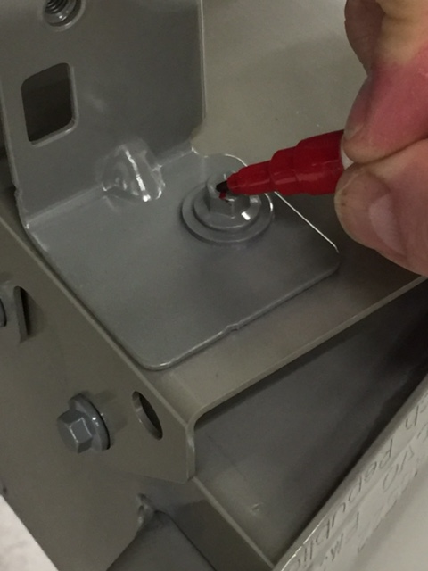

1. Down to the base

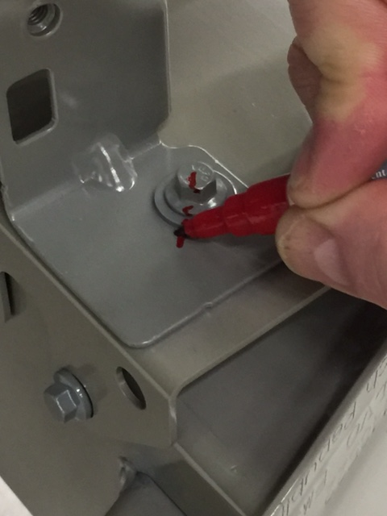 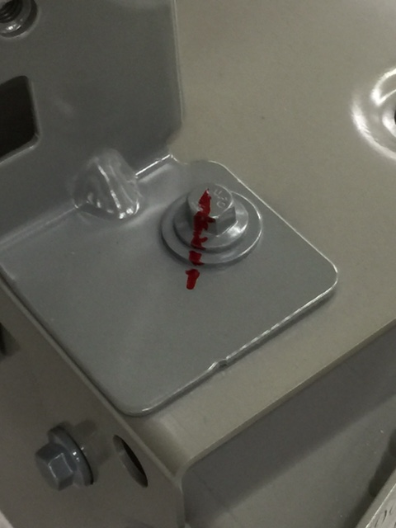

1. Add the digital torque wrench

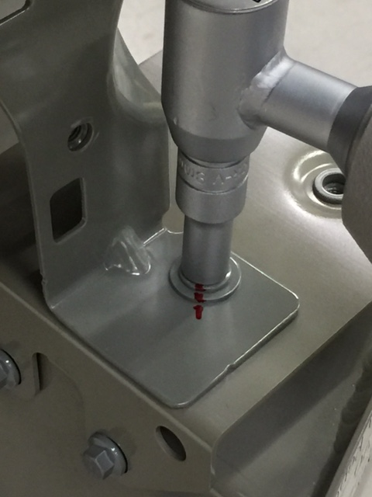

1. Loosen some ten degrees

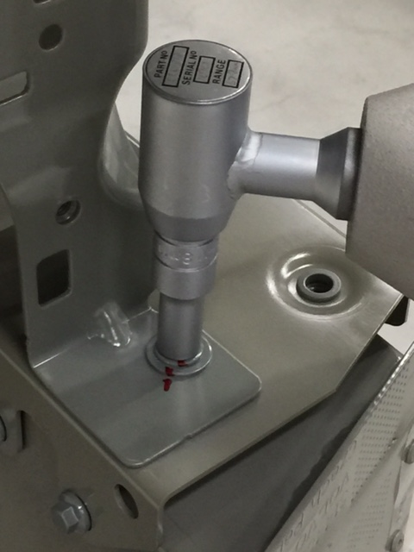

1. See how the mark on the screw head is now in a different position

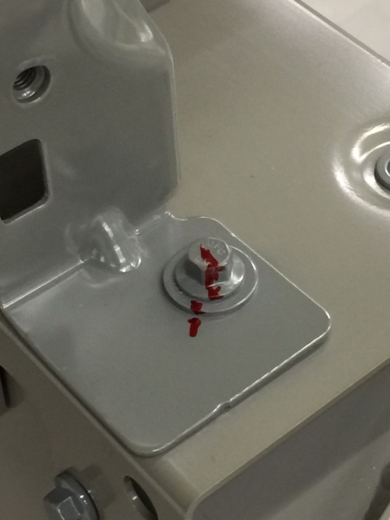

1. Add the digital torque wrench again

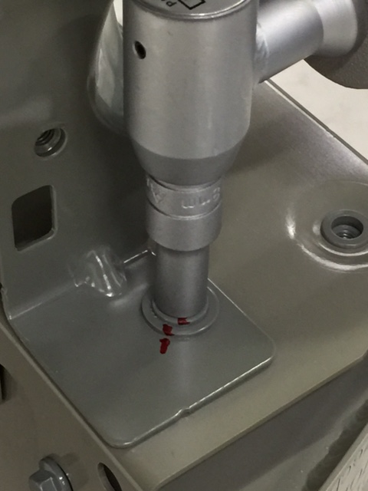

1. Tighten back to the mark on the base

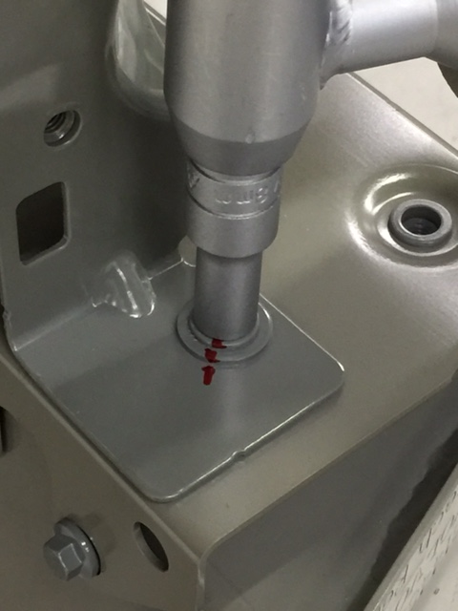

1. Read the torque in the digital torque wrench display

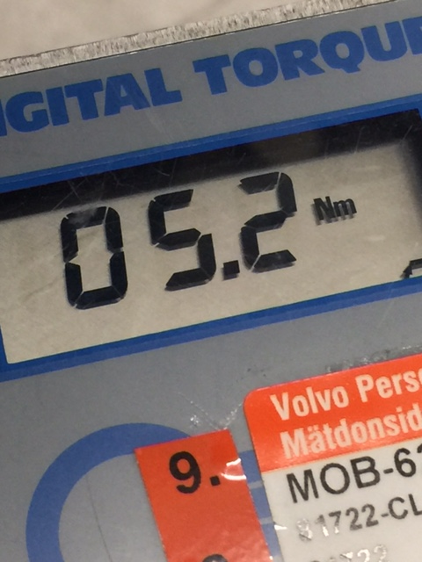

1. Check that the mark was back to the starting position

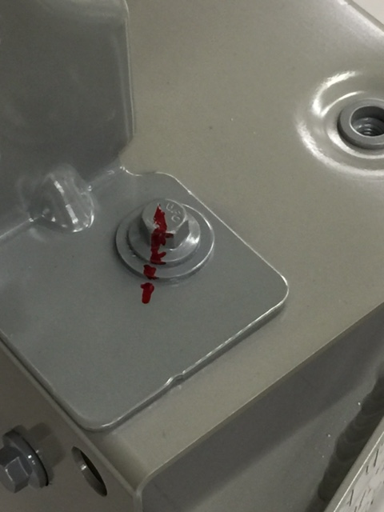

1. The read torque of 5.2Nm can now be considered as the residual torque

If the screw during this measurement did not separate and gave a torque above half the assembly torque the joint can be considered OK.

Best regards /Christer Larsson and Thomas Hermansson +463152387